AI TRIP PLANNER APP UI PROMPT

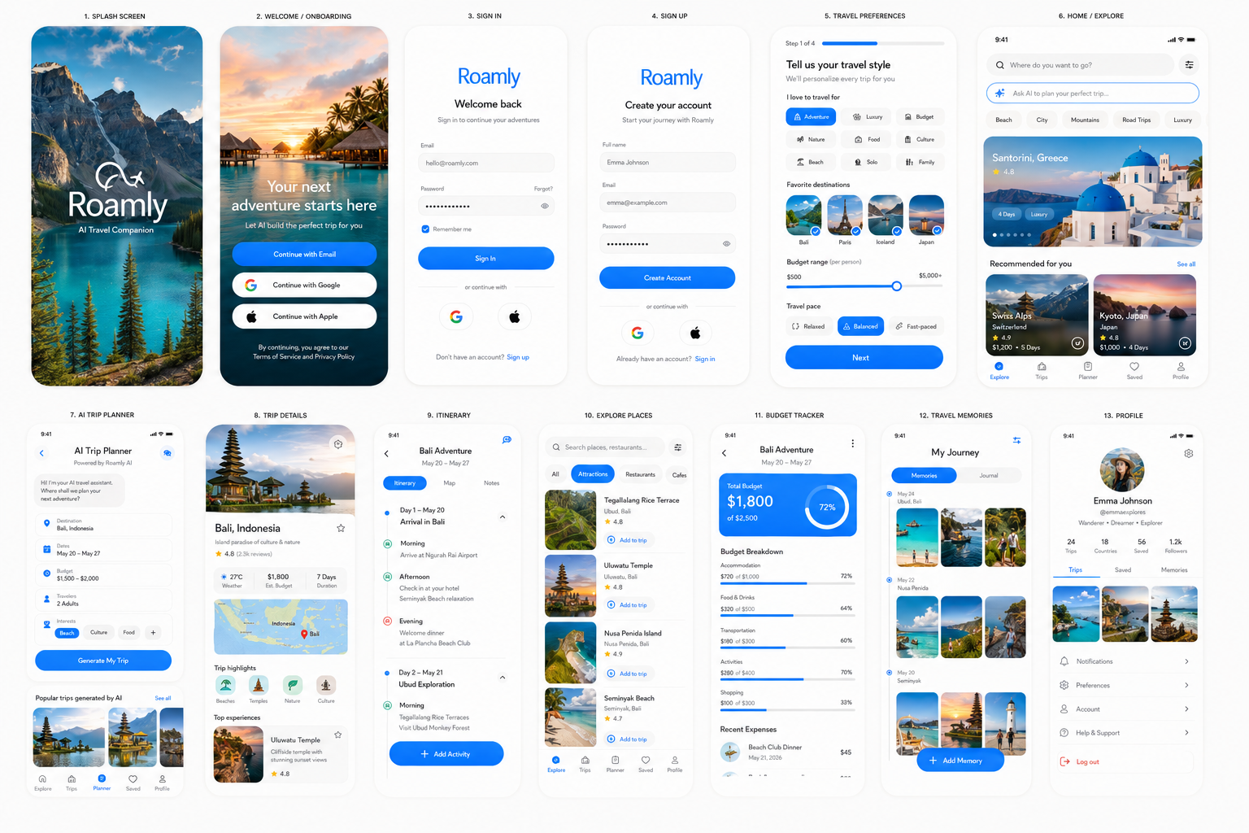

Generate an image of a complete modern mobile app UI design system and all screen designs for an AI-powered travel planning app called "Roamly".
Roamly is a modern AI travel companion that helps users discover destinations, build personalized itineraries, organize trips, track travel plans, and share travel experiences.

The app helps users:
- Discover destinations around the world
- Generate AI-powered travel itineraries
- Organize flights, hotels, and activities
- Save places to visit
- Create day-by-day travel schedules
- Explore restaurants, attractions, and hidden gems
- Collaborate with friends on trips
- Share travel memories and photos
- Track travel budgets
- Receive personalized recommendations

Design Style
- Ultra modern 2026 startup aesthetic
- Minimalistic, clean, editorial layouts
- Premium travel-magazine feel
- Light mode first with airy white space
- Large immersive destination photography as the hero of every screen
- Soft rounded corners (16–20px radius)
- Subtle depth, premium shadows, floating cards
- Pill-shaped buttons and filter chips
- Smooth spacing and polished interactions
- Aspirational, adventurous, inspiring vibe
- NOT cluttered, NOT corporate, NOT generic travel agency style
- Apple-level clean UI mixed with luxury travel branding

Color Palette
- Crisp white and soft off-white backgrounds (#FFFFFF / #FAFAF8)
- Deep ocean blue primary accent (#3A86FF)
- Sky blue gradients and sunset orange highlights
- Deep charcoal text (#1F1F1F)
- Soft gray secondary text (#8A8A8A)
- Subtle teal and emerald accents for recommendations
- Premium glassmorphism effects on selected components

Typography
- Clean modern sans-serif (SF Pro / Inter style)
- Large editorial destination headlines
- Strong hierarchy: bold headings, medium subheads
- Comfortable readable body text
- Prominent travel metadata pills ("4 Days", "Budget", "Family Friendly", "Adventure")

Screens

1. Splash Screen
- Roamly logo centered
- Beautiful destination image blurred in background
- Minimal branding
- Premium travel startup feel

2. Welcome / Onboarding Screen
- Full-screen breathtaking travel photography
- Soft gradient overlay
- Headline: "Your next adventure starts here"
- Subheadline: "Let AI build the perfect trip for you"
- Continue with Email
- Continue with Google
- Continue with Apple
- Pill-shaped buttons
- Small terms and privacy text

3. Authentication Screens
- Sign In
- Sign Up
- Google Login
- Apple Login
- Clean rounded inputs
- Modern travel aesthetic
- Ocean-blue primary CTA

4. Travel Preferences Onboarding
- Trip style selection chips: Adventure, Luxury, Budget, Nature, Food, Culture, Beach, Solo, Family
- Favorite destinations selector
- Budget range slider
- Travel pace selector
- Interests selection grid
- Progress indicator at top

5. Home / Explore Screen
Include:
- Large search bar: "Where do you want to go?"
- AI prompt input
- Horizontal destination categories: Beach, City, Mountains, Road Trips, Luxury, Food
- Featured destination hero card
- Personalized recommendations section
- Trending destinations carousel
- Large destination cards with: destination image, country, rating, estimated budget, trip duration, save button

6. AI Trip Planner Screen
- AI chat-style interface
- Trip generation form
- Destination field
- Travel dates
- Budget selector
- Travel companions selector
- Interests chips
- Large CTA: "Generate My Trip"
- Beautiful generated itinerary preview cards

7. Trip Details Screen
- Large immersive destination image carousel
- Destination overview
- Weather summary
- Budget estimate
- Interactive map preview
- Trip highlights
- Recommended restaurants
- Top attractions
- Save trip button
- Share button

8. Itinerary Screen
- Beautiful timeline layout
- Day-by-day schedule
- Morning / afternoon / evening sections
- Activity cards
- Maps integration preview
- Transport suggestions
- Editable itinerary blocks
- Floating add activity button

9. Explore Places Screen
- Search places
- Restaurants, cafes, attractions, hidden gems, shopping, nightlife
- Interactive filter chips
- Large destination imagery
- Save-to-trip action

10. Budget Tracker Screen
- Trip spending summary
- Budget progress bars
- Expense categories: accommodation, food, transportation, activities, shopping
- Beautiful financial cards
- Travel-friendly visualizations

11. Travel Memories Screen
- Photo gallery grid
- Travel journal entries
- Timeline layout
- Large destination photos
- Location tags
- Share memories CTA

12. Saved Trips Screen
- Grid of saved trips
- Organized collections: Dream Trips, Upcoming, Completed, Favorites
- Warm empty state
- Beautiful travel illustrations

13. Profile Screen
- Large circular avatar
- Travel stats: countries visited, trips completed, saved destinations
- Follower/following counts
- Tabs: Trips, Saved, Memories
- Grid of travel photos
- Settings rows: notifications, preferences, account, help
- Red log out button

Direction
Design the app like a real App Store travel startup product. Make every screen feel connected through one cohesive design system.
The experience should feel: premium, aspirational, luxurious, modern, minimal, travel-focused, beautiful, highly polished, emotionally inspiring.
Generate high-quality mobile app mockups in iPhone style with realistic spacing, premium destination photography, modern travel UX, and production-ready startup design quality.

RECIPE APP UI PROMPT
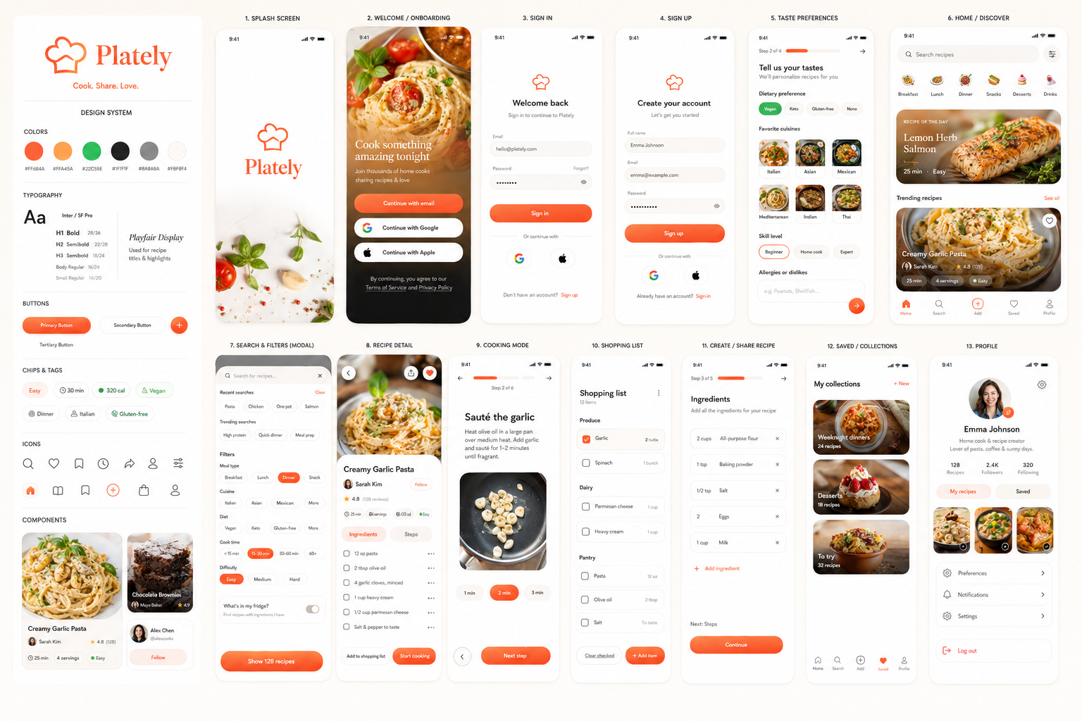

Generate an image of a complete modern mobile app UI design system and all screen designs for a recipe and meal-sharing app called "Plately".
Plately is a modern community-driven cooking app where people discover, save, cook, and share delicious recipes.

The app helps users:
- Discover recipes through a beautiful feed
- Search and filter by cuisine, diet, and meal type
- View step-by-step cooking instructions
- Save favorite recipes to collections
- Build and check off shopping lists
- Share their own recipes with photos
- Follow favorite creators
- Rate and review dishes

Design Style
- Ultra modern 2026 startup aesthetic
- Minimalistic, clean, editorial layouts
- Premium food-magazine feel
- Light mode first with warm, airy white space
- Large, mouth-watering food photography as the hero of every screen
- Soft rounded corners (16–20px radius)
- Subtle drop shadows and gentle depth
- Pill-shaped buttons and filter chips
- Smooth spacing, highly polished
- Warm, appetizing, inviting vibe
- NOT cluttered, NOT corporate, NOT boxy
- Apple-level clean UI mixed with a cozy, friendly food brand

Color Palette
- Crisp white & warm off-white (#FFFFFF / #FBF8F4) backgrounds
- Fresh accent color — warm coral-orange (#FF6B4A) primary
- Deep charcoal text (#1F1F1F) and soft gray secondary text (#8A8A8A)
- Subtle orange-to-amber gradient for key CTAs and highlights
- Fresh green secondary accent for tags (vegan, healthy, time)
- Premium rounded cards with soft shadows
- Clean rating, time, and calorie typography

Typography
- Clean modern sans-serif (Inter / SF Pro style) with an optional elegant serif for recipe titles
- Strong Apple-like hierarchy
- Bold headings, medium subheads, readable body
- Prominent metadata pills ("30 min", "320 cal", "Easy")

Screens

1. Splash Screen
- Plately logo centered
- Minimal branding on a clean white or soft warm-gradient background
- Premium, appetizing first impression

2. Welcome / Onboarding Screen
- Full-bleed stunning food photo with soft gradient overlay
- Motivational headline ("Cook something amazing tonight")
- "Continue with email", "Continue with Google", "Continue with Apple" pill buttons
- Small terms & privacy text

3. Authentication Screens
- Sign In
- Sign Up
- Google login
- Apple login
- Email/password forms with clean rounded inputs and a coral-orange primary button

4. Taste Preferences Onboarding
- Dietary preference selection (vegan, keto, gluten-free, none) as chips
- Favorite cuisines grid (Italian, Asian, Mexican, Mediterranean)
- Cooking skill level selector
- Allergies/dislikes input
- Clean progress indicator at top

5. Home / Discover Feed
Include:
- Top search bar pill ("Search recipes") with a filter icon
- Horizontal scrollable category row with icons (Breakfast, Lunch, Dinner, Snacks, Desserts, Drinks)
- Featured "Recipe of the day" hero card
- Vertical feed of large rounded recipe cards, each with a big food photo, heart/save icon top-right, title, creator avatar, star rating, and metadata pills ("25 min · 4 servings · Easy")

6. Search & Filters Screen
- Modal sheet
- Search input with recent & trending searches
- Filter chips: meal type, cuisine, diet, cook time, difficulty
- Ingredient-based filter ("what's in my fridge")
- Large coral-orange "Show recipes" button

7. Recipe Detail Screen
Include:
- Large food image carousel at top with back / share / heart icons overlaid
- Title, creator avatar row, star rating + review count
- Metadata pills row (time, servings, calories, difficulty)
- Segmented tabs "Ingredients / Steps"
- Ingredients list with checkboxes and "Add to shopping list"
- Numbered step-by-step instructions with optional step images
- Sticky bottom bar with "Start cooking" button

8. Cooking Mode Screen
- Full-screen step-by-step view, one step at a time
- Large step number and instruction text
- Progress bar across the top
- Built-in timer chips for timed steps
- Swipe / next-step navigation, keep-screen-awake feel

9. Shopping List Screen
- Ingredients grouped by category (Produce, Dairy, Pantry)
- Checkable rounded list items
- Quantity labels
- "Clear checked" and "Add item" actions
- Clean empty-state illustration variant

10. Create / Share Recipe Screen
- Multi-step form with progress indicator at top
- Title & description text fields
- Photo upload area: grid of added images plus an "add photo" tile
- Ingredients builder (add rows with amount + item)
- Steps builder (add numbered steps with optional photos)
- Category, cuisine, time, and servings selectors
- Coral-orange "Publish recipe" button

11. Saved / Collections Screen
- Grid of saved recipes with filled heart icons
- Organized into custom collections (Weeknight dinners, Desserts, To try)
- Warm empty-state variant

12. Profile Screen
Include:
- Circular avatar with edit badge
- Name, bio, and follower/following counts
- Tabs for "My recipes" and "Saved"
- Grid of the user's posted recipes
- Menu rows with icons (Preferences, Notifications, Settings)
- Red "Log out" row at the bottom

Direction
Design the app like a real App Store food startup product. Make all screens consistent and connected with the same design system.
The UI should feel: appetizing, warm and inviting, premium, modern, simple, highly polished.
Generate high quality mobile app mockups in iPhone style with realistic spacing and clean UX.

DATING APP UI PROMPT

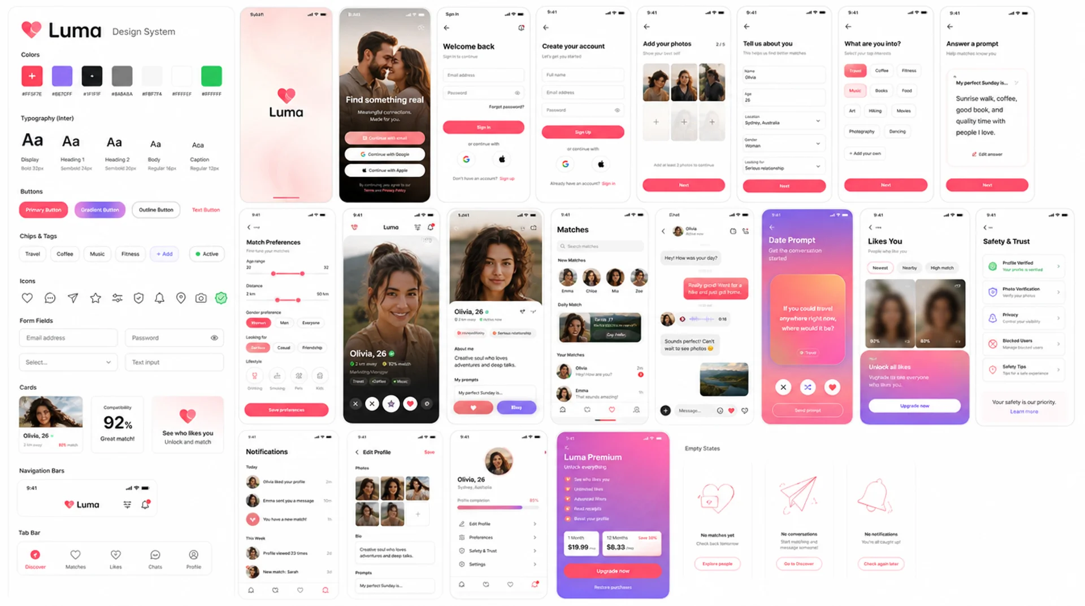

Generate an image of a complete modern mobile app UI design system and all screen designs for a dating app called "Luma".
Luma is a premium, modern dating app designed to help people form genuine romantic connections through thoughtful profiles, beautiful discovery flows, personality-based matching, and warm conversation design.

The app helps users:
- Discover compatible people through a beautiful swipe/card feed
- Browse curated daily matches
- Search and filter by interests, lifestyle, location, and relationship goals
- View rich user profiles with photos, prompts, interests, and compatibility insights
- Like, pass, super-like, and save profiles
- Match with people and start conversations
- Send messages, reactions, voice notes, and date prompts
- Answer personality prompts to improve matches
- Manage preferences, safety settings, and privacy controls
- Edit their profile with photos, bio, interests, and dating intentions

Design Style
- Ultra modern 2026 startup aesthetic
- Minimalistic, clean, emotionally warm layouts
- Premium lifestyle-magazine feel
- Light mode first with soft airy white space
- Large, beautiful lifestyle photography as the hero of every profile screen
- Soft rounded corners, 18–24px radius
- Subtle drop shadows and gentle depth
- Pill-shaped buttons, tags, filters, and interest chips
- Smooth spacing, polished hierarchy, highly refined UX
- Warm, romantic, inviting vibe
- NOT cluttered, NOT corporate, NOT childish
- Apple-level clean UI mixed with a soft, premium relationship brand
- Sleek, elegant, emotionally intelligent, and trustworthy

Color Palette
- Crisp white and warm off-white backgrounds: #FFFFFF / #FBF7F4
- Romantic primary accent: warm rose-coral #FF5F7E
- Secondary accent: soft lavender #8E7CFF
- Deep charcoal text: #1F1F1F
- Soft gray secondary text: #8A8A8A
- Subtle rose-to-lavender gradients for key CTAs and match moments
- Fresh green accent for verified, active, and safety states
- Premium rounded cards with soft shadows
- Clean compatibility, distance, and interest typography

Typography
- Clean modern sans-serif, Inter / SF Pro style
- Optional elegant serif for romantic headlines and profile names
- Strong Apple-like hierarchy
- Bold headings, medium subheads, readable body text
- Prominent metadata pills such as "2 km away", "92% match", "Active now", "Looking for serious"

Screens

1. Splash Screen
- Luma logo centered
- Minimal branding on a clean white or soft rose-gradient background
- Premium, romantic first impression

2. Welcome / Onboarding Screen
- Full-bleed beautiful lifestyle couple or portrait photography with soft gradient overlay
- Motivational headline: "Find something real"
- Subheadline about meaningful connections
- "Continue with email", "Continue with Google", "Continue with Apple" pill buttons
- Small terms and privacy text

3. Authentication Screens
- Sign In
- Sign Up
- Google login
- Apple login
- Email/password forms with clean rounded inputs
- Soft rose-coral primary button
- Forgot password and account recovery links

4. Profile Setup Onboarding
- Multi-step onboarding with clean progress indicator at top
- Photo upload grid with add-photo tiles
- Name, age, gender identity, location, dating intention
- Relationship goals selector: serious, casual, friendship, unsure
- Interests selection chips: travel, coffee, fitness, books, music, food, art
- Personality prompt selection and answer input
- Clean "Next" and "Complete profile" CTAs

5. Match Preferences Screen
- Age range slider
- Distance slider
- Gender preference selector
- Relationship goal filters
- Lifestyle filters such as drinking, smoking, pets, kids, religion
- Interest-based filters
- Clean modal-style layout with large "Save preferences" button

6. Home / Discover Feed
- Large profile card stack with full-screen portrait photography
- Top navigation with logo, location, filter icon, and notifications
- Profile card includes name, age, location, verification badge, match percentage, and short bio
- Interest chips overlaid at bottom of card
- Floating action buttons: pass, like, super-like, message
- Smooth premium card shadows and rounded image corners
- Subtle gradient overlay for text readability

7. Profile Detail Screen
- Large photo carousel at top with back, share, report, and like icons overlaid
- Name, age, verified badge, distance, active status
- Bio section
- Dating intention pill
- Compatibility score card
- Prompt answers with elegant cards
- Interests and lifestyle tags
- Photo gallery grid
- Sticky bottom bar with "Like" and "Send message" buttons

8. Matches Screen
- Top section for new matches with horizontal circular avatars
- Daily curated match card
- List of matched users with photo, name, last message preview, timestamp, unread badge
- Empty-state variant with soft romantic illustration
- Clean search bar for matches

9. Chat / Messaging Screen
- Modern message thread UI
- Profile header with avatar, name, active status, call/video icons
- Soft rounded chat bubbles
- Date prompt suggestions
- Voice note bubble
- Photo sharing preview
- Reaction chips
- Typing indicator
- Bottom message composer with plus, text input, emoji, and send button
- Warm, safe, friendly tone

10. Date Prompt / Icebreaker Screen
- Curated question cards like "What's your perfect Sunday?"
- Fun prompt categories: playful, deep, travel, food, values
- Large swipeable prompt cards
- "Send prompt" CTA
- Beautiful soft gradient background

11. Likes You Screen
- Premium grid of people who liked the user
- Blurred profile cards for locked/free state variant
- Unlocked premium version with clear photos
- Filter chips for newest, nearby, high compatibility
- Upgrade CTA card with rose-to-lavender gradient

12. Safety & Trust Screen
- Verification status card
- Photo verification flow
- Block and report tools
- Privacy controls
- Location visibility settings
- Profile visibility toggle
- Friendly safety tips cards
- Clean trustworthy design, not scary or corporate

13. Notifications Screen
- Activity feed showing new likes, matches, messages, profile views, and app tips
- Rounded notification rows with avatars and icons
- Grouped sections: Today, This Week, Earlier
- Clear unread states

14. Edit Profile Screen
- Photo management grid
- Drag-and-drop style photo ordering
- Bio text field
- Prompt answer editor
- Interest chips editor
- Basic info rows
- Relationship goal selector
- Save changes button

15. Profile / Account Screen
- Large circular avatar with edit badge
- Name, age, location
- Profile completion percentage
- Tabs or cards for Edit Profile, Preferences, Subscription, Safety, Settings
- Menu rows with icons
- Red "Log out" row at the bottom

16. Premium / Subscription Screen
- Beautiful premium upgrade page
- Soft rose-to-lavender gradient hero
- Feature cards: See who likes you, Unlimited likes, Advanced filters, Read receipts, Boost profile
- Monthly and yearly pricing cards
- Large "Upgrade now" CTA
- Small restore purchase and terms links

Direction
Design the app like a real App Store dating startup product. Make all screens consistent and connected with the same design system.
The UI should feel: romantic, safe, premium, modern, simple, human, emotionally warm, highly polished.
Generate high-quality mobile app mockups in iPhone style with realistic spacing, clean UX, modern typography, and beautiful photography. Show the full design system including color palette, typography, buttons, chips, cards, icons, form fields, navigation bars, tab bars, profile cards, chat bubbles, and empty states.

CALORIE TRACKER APP UI PROMPT

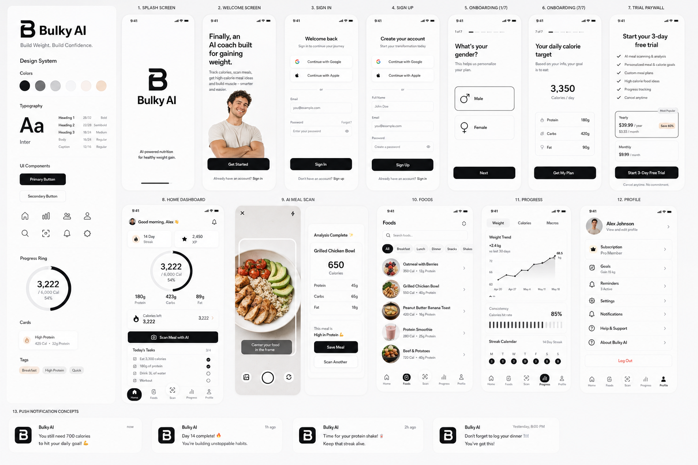
Generate a complete modern mobile app UI design system and screen designs for a fitness mobile app called “Bulky AI”.
Bulky is a modern AI-powered fitness app designed specifically for skinny people who want to gain weight and build muscle.
The app helps users:
- track calories
- gain weight
- stay consistent
- analyze meals using AI
- build muscle
- follow high calorie food ideas
- maintain streaks and habits
Design style:
- ultra modern 2026 startup aesthetic
- minimalistic UI
- clean layouts
- smooth spacing
- premium mobile design
- dark mode first
- subtle gradients
- rounded corners
- glassmorphism only slightly if needed
- easy navigation
- highly polished
- visually motivating
- fitness & self-improvement vibe
- NOT cluttered
- NOT bodybuilding style
- more like Apple-level clean UI mixed with modern fitness startup aesthetics
Color palette:
- dark charcoal backgrounds
- soft whites
- subtle electric blue accents
- slight cyan gradients
- modern neutral tones
- premium looking cards
- soft shadows
- smooth charts
Typography:
- clean sans-serif
- modern Apple-like hierarchy
- bold headings
- easy readability
The app should contain the following screens:
- Splash Screen
- Bulky logo
- minimal branding
- dark premium aesthetic
- Welcome Screen
- motivational headline
- clean illustration or fitness visual
- CTA buttons
- Authentication Screens
- Sign In
- Sign Up
- Google login
- Apple login
- Email/password forms
- Onboarding Screens
- gender selection
- height input
- weight input
- goal weight
- activity level
- gym experience
- goal type
- calorie target result screen
- Trial Paywall Screen
- 3 day free trial
- monthly/yearly pricing
- premium feature list
- modern subscription cards
- trustworthy clean design
- Home Dashboard Include:
- calorie progress ring
- protein progress
- daily streak
- quick AI scan button
- motivational message
- current weight
- calories remaining
- XP/progress system
- daily tasks
- AI Meal Camera Screen
- large camera preview
- scan food CTA
- AI analyzing state
- results modal
- calories/macros breakdown
- Foods Screen Categories:
- breakfast
- lunch
- dinner
- snacks
- shakes
Include:
- food cards
- calorie labels
- protein labels
- food thumbnails
- clean scrollable layout
- Progress Screen Include:
- weight graph
- streak calendar
- calorie consistency charts
- transformation progress section
- weekly summaries
- Profile Screen Include:
- subscription status
- goals
- reminders
- settings
- notification preferences
- logout
- Push Notification UI Concepts Show examples like:
- “You still need 700 calories today”
- “Day 14 complete”
- “Time for your protein shake”
Design the app like a real App Store startup product.
Make all screens consistent and connected with the same design system.
The UI should feel:
- addictive
- motivating
- premium
- modern
- simple
- highly polished
Generate high quality mobile app mockups in iPhone style with realistic spacing and clean UX.

DENTAL APP UI

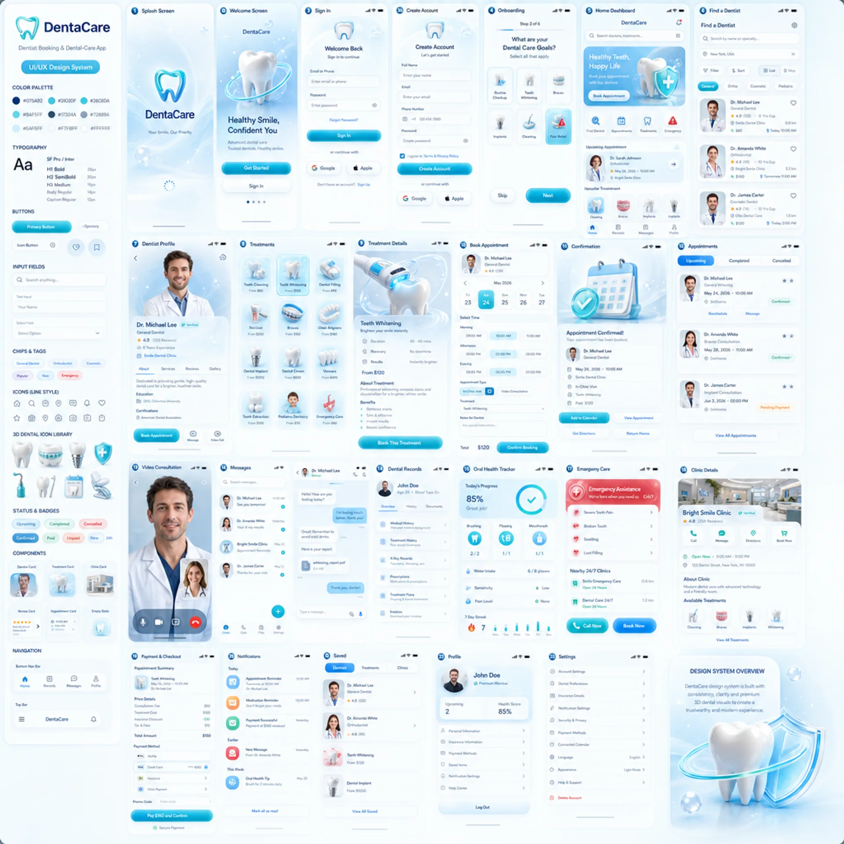

Create an ultra-high-resolution UI showcase board for a premium dental-care mobile app called "DentaCare" — a modern digital dentistry platform for finding dentists, booking appointments, video consultations, dental records, and treatment tracking.

PRESENTATION
Large professional UI presentation board. Multiple iPhone screens arranged in a clean, evenly spaced grid on a bright icy-blue background. Consistent device frames and screen dimensions, no overlapping, all screens fully visible, crisp readable UI text, accurate iOS status bars, 16:9 landscape board.

DESIGN STYLE
Ultra-modern 2026 healthcare startup aesthetic. Premium futuristic dental branding — soft, elegant, reassuring, highly polished. Light mode with luminous icy-blue backgrounds. Translucent glassmorphism cards and floating panels, frosted-glass surfaces with subtle inner highlights, soft cyan and aqua edge glows. Rounded corners 18–28px. Large floating cards with smooth premium shadows, layered transparency, soft volumetric lighting and ambient glow. Pill-shaped buttons, tabs, selectors, and input fields. Minimal layouts with generous spacing. Apple-level mobile UX with premium medical branding — friendly and trustworthy, not cold or clinical. Consistent glossy 3D visual language across every screen. NOT flat, NOT generic, NOT corporate, NOT overly colorful, NOT childish, NOT cluttered. No dark medical imagery, no blood, no damaged teeth, no intimidating procedures.

3D VISUAL ASSETS
Glossy pearlescent white molar teeth with realistic smooth enamel, translucent aqua medical shields, dental implants with ceramic crowns, orthodontic braces, whitening equipment, dental cleaning tools, glowing medical crosses, floating glass bubbles, cyan orbital rings, sparkling light particles, soft star highlights, frosted-glass calendar icons, semi-realistic 3D dentist avatars. All rendered like high-end Cinema 4D / Octane renders — realistic materials, polished reflections, smooth rounded geometry, soft shadows, subtle volumetric lighting.

COLOR PALETTE
Backgrounds #FFFFFF and #F7FBFF · powder blue surfaces #EAF6FF · sky-blue gradients #C9E9FF → #7FCBFF · deep dental blue #075A92 · aqua primary #24D4DF · turquoise #26C6DA · cyan glow #8AF5FF · navy text #17324A · blue-gray secondary text #72889A. Translucent white glass cards with subtle blue borders. Selected states use blue-to-cyan gradients. Glow used selectively; maintain strong readability.

TYPOGRAPHY
Clean modern sans-serif in the spirit of SF Pro and Inter. Large bold healthcare headlines, medium-weight section titles, comfortable body text, compact labels for dates, prices, ratings. Rounded pill-shaped metadata chips. Strong hierarchy, no decorative fonts.

SCREENS TO INCLUDE
1. Splash — glowing aqua glass tooth logo, sparkles, loading indicator
2. Welcome — hero 3D molar with cyan orbital ring, frosted panel, "Healthy Smile, Confident You", pill "Get Started" + "Sign In"
3. Sign In / Create Account — glass inputs, Google, Apple, phone login, cyan gradient CTA
4. Patient Onboarding — progress bar, translucent selection cards for checkups, whitening, braces, implants, tooth pain, cleaning, cosmetic, emergency
5. Home Dashboard — search field, filter button, hero card "Healthy Teeth, Happy Life" with 3D tooth + aqua shield, quick actions (Find Dentist, Appointments, Treatments, Emergency), upcoming appointment card, popular treatments, recommended dentists carousel, bottom nav (Home, Records, Messages, Profile)
6. Find a Dentist — search, location selector, specialty chips, dentist cards with rating, experience, distance, price, next available, map/list toggle
7. Dentist Profile — large portrait, verified badge, about, certifications, treatments, reviews, clinic gallery, map, Book / Message / Video Consult / Save
8. Treatment Categories — grid of glossy 3D treatment icons with name, description, price
9. Treatment Details — immersive 3D tooth with glowing cyan whitening tool and translucent protective bubble, duration, recovery, benefits, before/after, fixed "Book This Treatment"
10. Book Appointment — dentist summary, horizontal date selector, time-slot pills, In-Clinic vs Video toggle, treatment selector, notes, total, "Confirm Booking"
11. Appointment Confirmed — 3D calendar with tooth, aqua success checkmark, details, Add to Calendar / Directions
12. Appointments — Upcoming / Completed / Cancelled tabs, timeline-styled cards with status badges
13. Video Consultation — telehealth UI, large dentist video, patient preview, floating translucent controls, timer, notes panel
14. Messages — conversation list plus chat with translucent bubbles, attachments, embedded appointment card
15. Dental Records — 3D glass folder and document icons, X-rays, prescriptions, treatment plans, invoices
16. Oral Health Tracker — brushing, flossing, mouthwash, water, progress ring, weekly score, streaks
17. Emergency Dental Care — reassuring emergency options, nearby 24h clinics, call and urgent booking
18. Clinic Details — clinic visual, hours, map, dentists, facilities, gallery, reviews
19. Payment & Checkout — cost breakdown, Apple Pay / card / insurance, promo code, "Pay and Confirm"
20. Notifications — grouped Today / This Week / Earlier with small 3D icons
21. Saved Dentists & Treatments — saved cards, collections, warm empty state with floating glossy tooth
22. Profile — circular avatar, membership, grouped translucent setting cards
23. Design System sheet — gradient buttons, glass buttons, circular icon buttons, search and text fields, date selectors, time-slot pills, filter chips, treatment / dentist / appointment / clinic / review cards, chat bubbles, status badges, payment cards, progress indicators, top and bottom navigation, modal sheets, dialogs, calendar, empty / loading / skeleton / success / error states, and a premium 3D dental icon library

ICONS
Thin rounded-line icons with soft aqua-to-blue gradients, consistent stroke width, selected icons inside translucent glowing squares. Glossy 3D icons for featured actions and treatment categories; outlined icons for navigation.

Render as a real premium App Store product — luminous, trustworthy, production-ready, one cohesive visual system across every screen.

